
2B Weekly Fridge Sheet
Monday, December7, 2015
Vocabulary Words to Know:

accident-something that happens by chance and may cause someone to be hurt

attention-giving thought or care to something

buddy-friend

enormous-very, very big

obeys-does what he or she is told to do

tips-helpful ideas
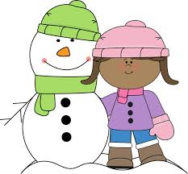

Spelling Words
Study….Test Friday

mule bugle fuse
use flute June
music duke tune
dune pony leaf
small who really
Challenge Words
*above
*color
*song
Skills We’re Learning:

Spelling:Long u-u, u_e

Reading:Read Ahead: Use illustrations and floor plan

Grammar:
Present-Tense Verbs
Subject-Verb Agreement
Commas in a series

Math:Place Value

Science: Earth's Surface

This Week:
Monday -Homework
-Vocabulary Sheet
-Booklet (pull off, fold, read, sign)
-Read Story: Officer Buckle & Gloria p.336-361
Friday-Spelling & Reading Tests
*Homework Due*

Important Dates:
Friday, Dec. 11 - 3rd-5th Christmas Program

*Sack Lunch will be provided on that day.

Have a Great Week! ☺Mrs. Rinehart
Sign, Clip, and Return Bottom Slip for a Token!

Student Signature:___________________ Parent Signature:_______________________
Expires 12/11/2015

